**Name:**

**Objectives:** The purpose of this activity is to use simulations in JMP to approximate the sampling distribution of the **sample mean**. Upon successful completion of this activity, you will be able to…

* Calculate the mean and standard error for a sampling distribution of a sample mean given population information and the sample size,
* Use JMP to draw a random sample of a given size,
* Simulate the sampling distribution of the sample mean,
* See the changes that take place in the shape of the sampling distribution of the sample mean as the sample size increases.

Delectable Delights is a large consumer food manufacturer selling its products in retail stores nationwide. You have landed your first job after graduation from Clemson in their advertising division. Since you took statistics as a part of your coursework, you are often called upon to perform data analysis for the advertising division, as well as other divisions of the company. The problem in this lab will be revisited in later labs.

**Directions:** Answer the following questions using complete sentences as though you were presenting your analysis to the employees of Delectable Delights. Please provide any appropriate output and/or screenshots from JMP. Instructions for creating several types of graphs or tables and statistics can be found on Canvas in the file **JMP Instructions.docx**. Paste your answers and any output into this document. Read directions carefully!

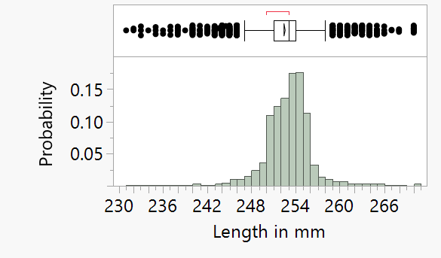**Sampling Distribution with Spaghetti Noodles (100 pts)**

STAT 3090 students in prior semesters measured the lengths of raw spaghetti noodles. This information was used to create a population of the lengths of spaghetti noodles for Delectable Delights.

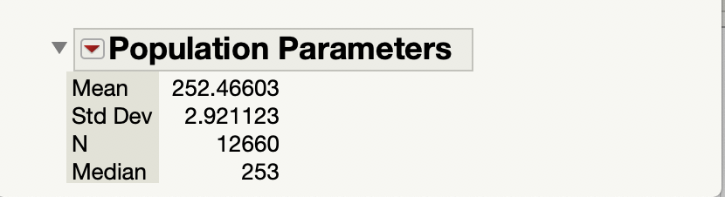Included here are the histogram and a few parameters for the **population** of spaghetti noodles. In this activity we will simulate a sampling distribution for a sample mean by drawing random samples of size 35 from this population of spaghetti noodles.

You will find the measurements for the spaghetti noodles in the file **Spaghetti Noodles.jmp.**

**Simulation**

1. Suppose that you have a **sample of size 35** from this population of spaghetti noodles. Let the random variable $X$ be the length of a spaghetti noodle. Calculate the mean and standard error for the sampling distribution of $\overline{X}$,the **sample mean**, for a sample of size 35. Use the population parameters for the length of the spaghetti noodles given above to make your calculations and please remember to give units. These are the **theoretical values** for this sampling distribution. (10 pts)

$μ_{\overline{X}}=$

$σ_{X}=$

Will the sampling distribution of the sample mean for a sample of size 35 in this case be approximately normally distributed? Explain why or why not.

1. 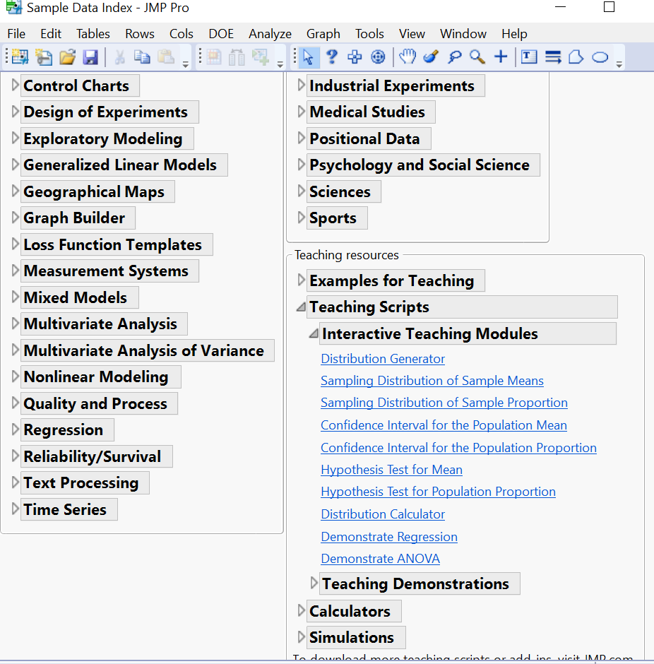We will now draw several random samples of 35 spaghetti noodles from the population of spaghetti noodles. To draw your first sample, open the file **Spaghetti Noodles.jmp** and select the column containing the spaghetti noodle lengths. Next, go to **Help >> Sample Data >> Teaching Scripts >> Interactive Teaching Modules >> Sampling Distribution of Sample Means**.

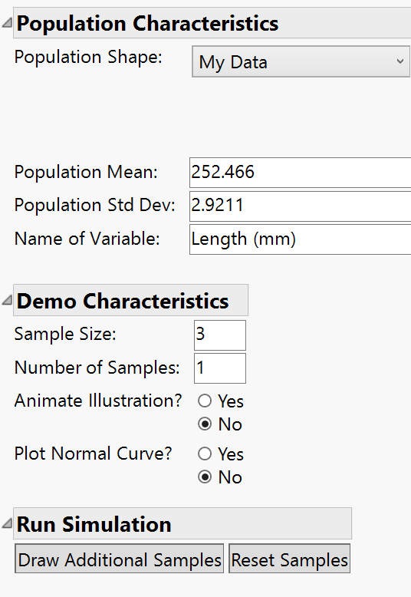In the **Population Characteristics** section, change the **Population** **Shape** to **My** **Data**. JMP will fill in the Population Mean and Standard Deviation. Note, the example screen shot may have different values for the mean and standard deviation.

In the **Demo** **Characteristics** section, enter the **Sample** **Size** of 35, and enter 1 for the **Number** **of** **Samples**. Under **Run Simulation,** select **Draw Additional Samples**.

5

JMP will draw one sample of size 35 from the population of spaghetti noodle lengths, produce a histogram of the sample and provide you with the mean and standard deviation of the sample. JMP will also plot the mean of the sample in a new histogram titled **Distribution of Sample Means**.

Repeat this process 9 more times by selecting **Draw Additional Samples**. As you draw each new sample, notice that the mean and standard deviation of each sample will change. Take your time here so that you don’t take too many samples. When you have a total of 10 samples, select the **red arrow** next to the histogram of the Distribution of the Sample Means and select **Make JMP Data Table** to have JMP create a table of the means and standard deviations of these 10 samples. Copy or take a screen shot of the data table and paste it in the space below. (10 pts)

1. We will now draw an additional 90 samples of size 35. In the **Run Simulation** section of the JMP module for **Sampling Distribution of Sample Means**, leave the **Sample** **Size** as 35 but change the **Number of Samples** to 90. Turn off the animation and choose **Draw Additional Samples**. JMP will now draw an additional 90 samples, each of size 35, and will plot the mean of each sample in the histogram at the bottom titled **Distribution of the** **Sample Means**. You have now taken 100 samples of size 35 and graphed 100 means in a histogram. Copy this **histogram** and the **Sample Means Summary Table** and paste them below. (10 pts)
2. Compare the **mean and standard deviation of Sample Means** from your simulation in Part c) above to the values for the **theoretical mean and standard error** of the sampling distribution that you found in Part a) by answering the following two questions.
3. Is the **mean** of Sample Means similar to or very different from the mean of the sampling distribution you found in Part a)?(5 pts)
4. Is the **standard deviation** of Sample Means similar to or very different from the standard error of the sampling distribution you found in Part a)? (5 pts)

**Summary**

We have simulated the sampling distribution of the sample mean for a sample of size 35 from the population of spaghetti noodles. Use what you observed in your simulation and what you’ve learned about sampling distributions in Chapter 8 to answer the questions below.

1. In general, if we **decrease** sample size, do we expect the mean of a sampling distribution to increase, decrease, or stay approximately the same? Explain your reasoning. (5 pts)

1. In general, if we **decrease** sample size, do we expect the standard error of a sampling distribution to increase, decrease, or stay approximately the same? Explain your reasoning. (Hint: Consider the formula for standard error.) (5 pts)
2. Use the **population mean and standard deviation** included in the JMP image on Page 1 of this lab (you may round them to two decimal places) to compute the following probabilities. For each answer, use **probability notation** and show your work to calculate a **z-score**. Be sure to use the correct z-score **formula** in each case and substitute in the values. You may find your final answer using either your calculator or the standard normal table. Round z-scores to **two** decimal places and probabilities to **four** decimal places.

(Hint: Follow a similar procedure to the problems in Example 8.2 on page 120 of the Lecture Guide.)

* 1. Find the probability that a **single** spaghetti noodle has a length of 253.1 mm or greater. (5 pts)
  2. Find the probability that a **random sample** of $n=35$ spaghetti noodles has a mean length of 253.1 mm or greater. (5 pts)